Q1. Write Single Data using FileOutputStream

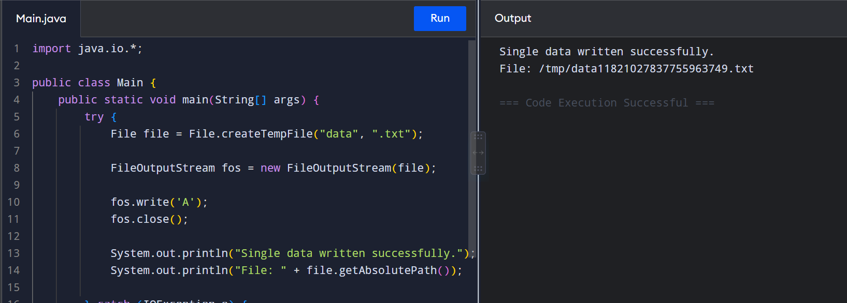

Q2. Read Single Data using FileInputStream
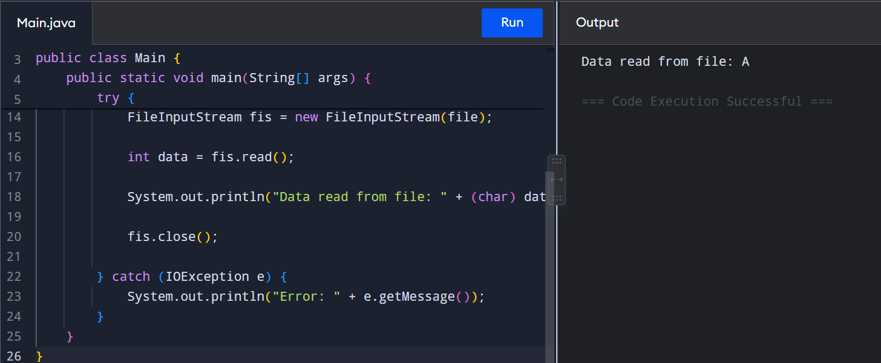

Q3. Write Bulk Data using FileOutputStream
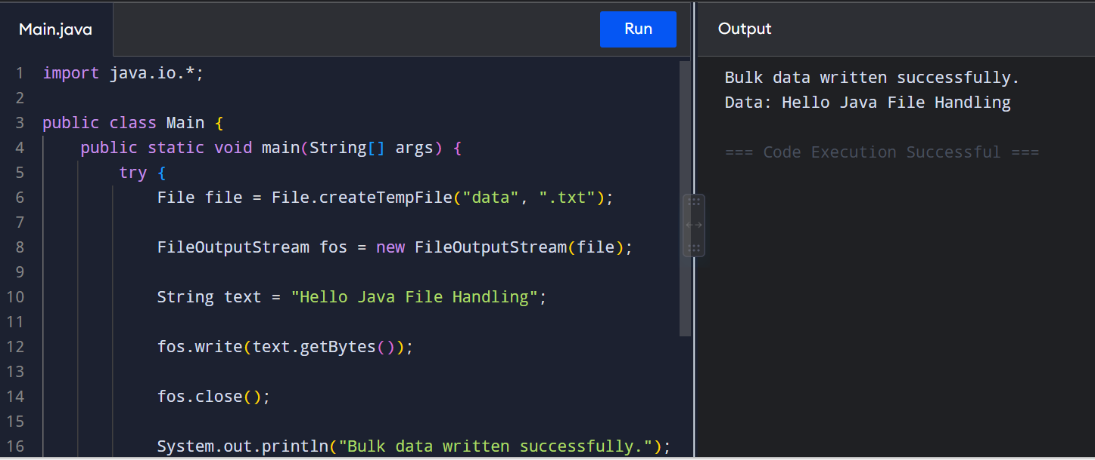

Q4. Read Bulk Data using FileInputStream
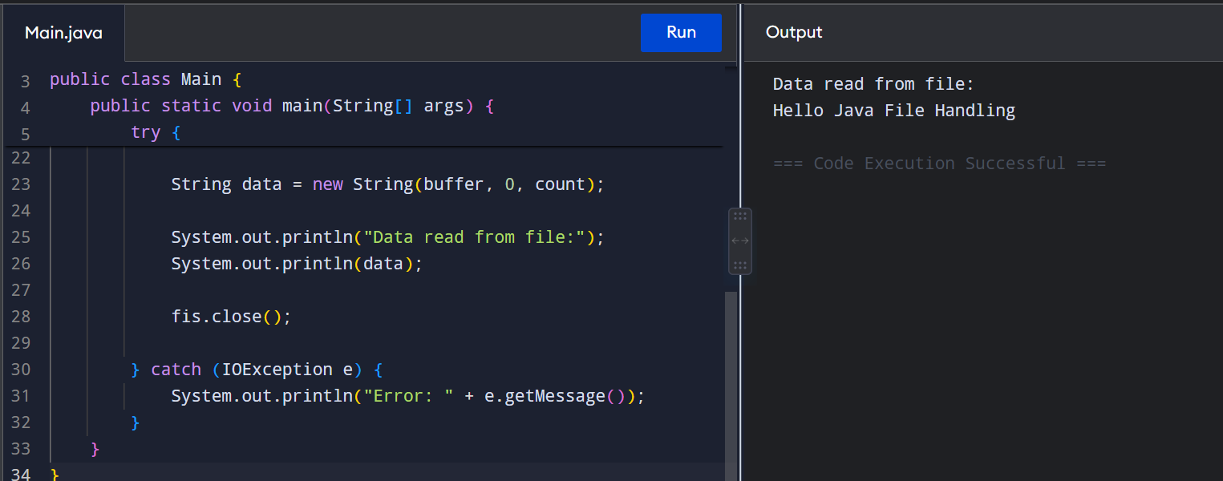
Q5. Write Single Data using FileWriter
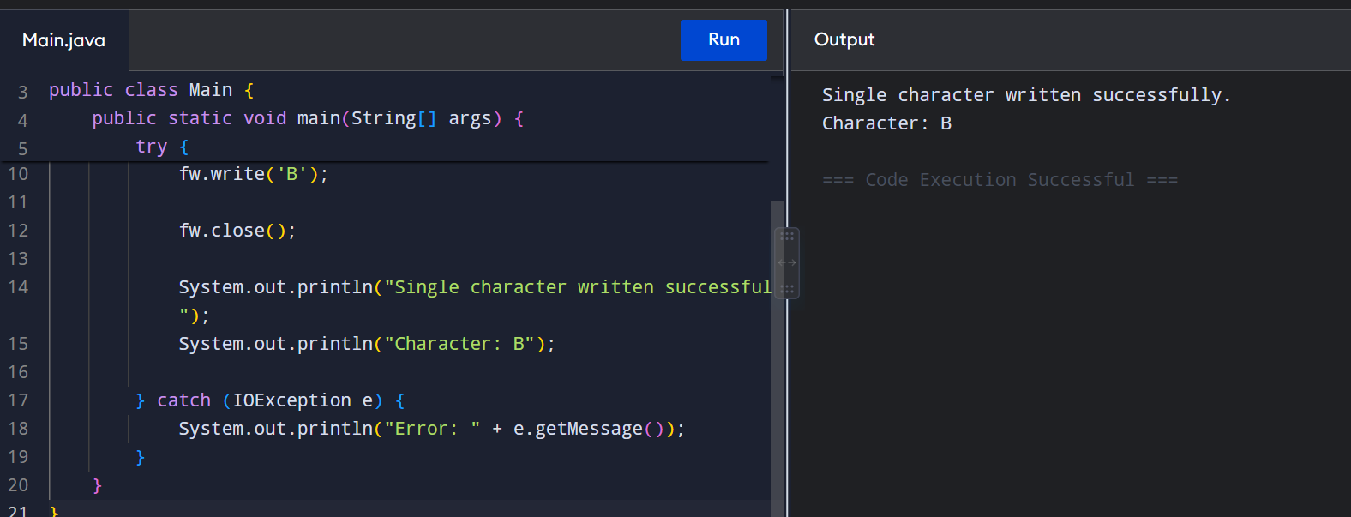
Q6. Read Single Data using FileReader
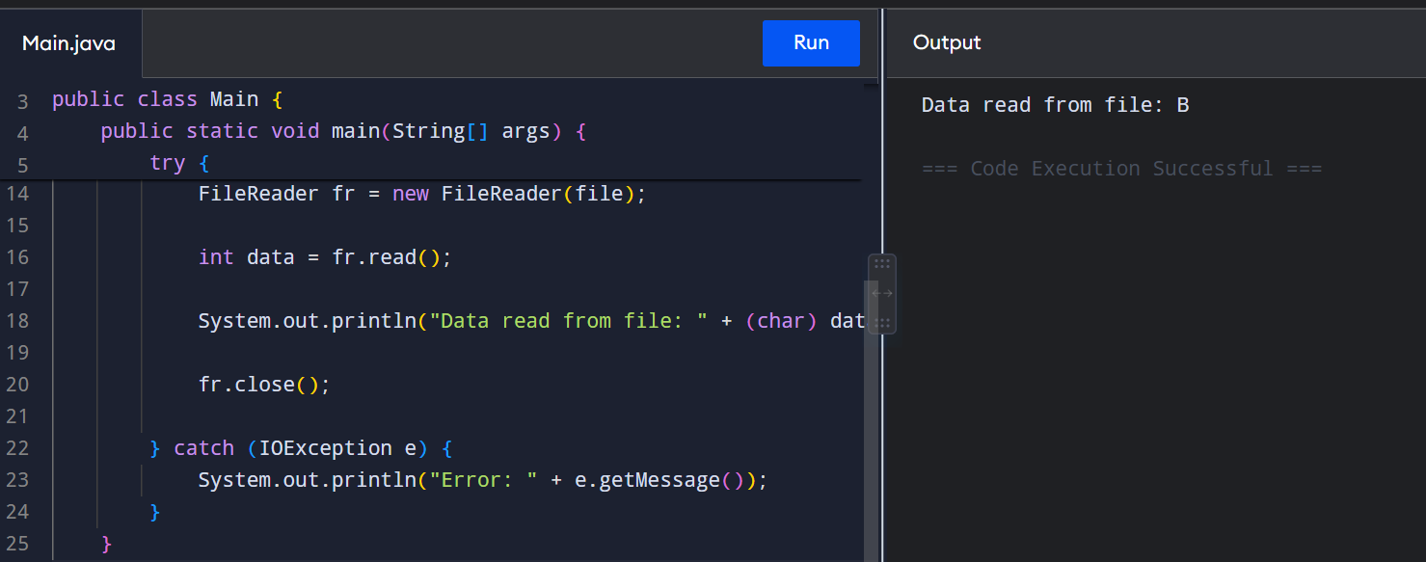

Q7. Write and Read Bulk Data using FileWriter and FileReader
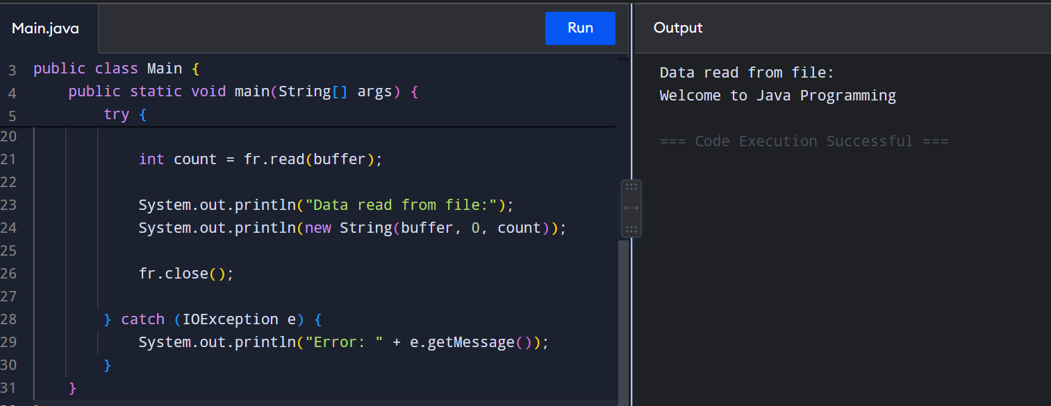
Q8. Find Number of Lines and Characters
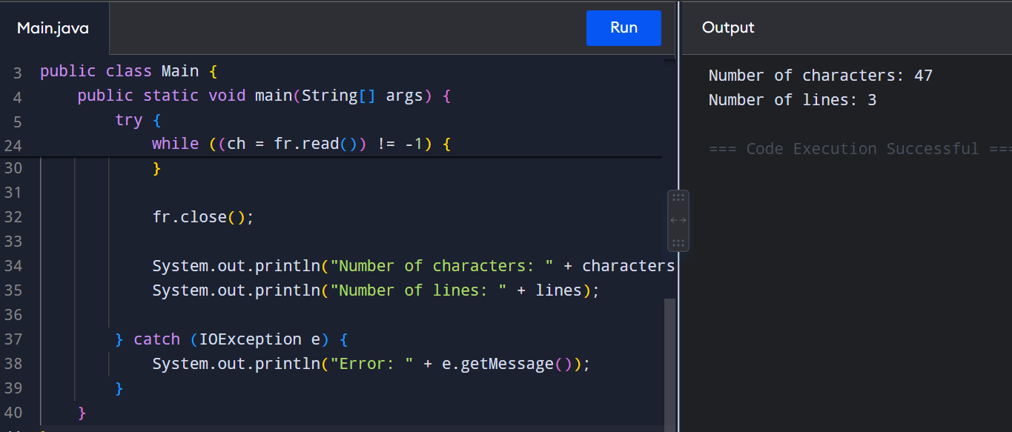
Q9. Two Files Read Mode and One File Write Mode
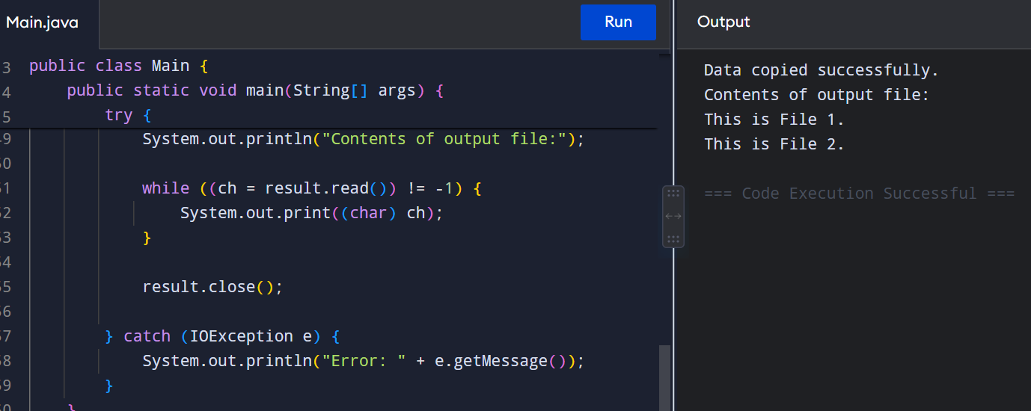
Q10. Combine Two Files using SequenceInputStream
